QUICKCARE AI
(AI Medical Assistant)

MAJOR PROJECT/DISSERTATION REPORT

Submitted by

MOHAMMAD KAIF SIDDIQUI
2021-350-025

in partial fulfillment for the award of the degree of

BACHELOR OF TECHNOLOGY COMPUTER SCIENCE
AND ENGINEERING (ARTIFICIAL INTELLIGENCE),

Under the supervision of

DR. IMRAN HUSSAIN


Department of Computer Science & Engineering
School of Engineering Sciences & Technology

JAMIA HAMDARD

(Deemed to be University)
New Delhi-110062

2025

DECLARATION

I, Mr. Mohammad Kaif Siddiqui a student of Bachelors of Technology in Computer Science (Artificial Intelligence) , (B.Tech CSE AI),(Enrolment No: 2021-350-025) hereby declare that the Project/Dissertation entitled“QUICKCARE AI AI MEDICAL ASSISTANT)” which is being submitted by me to the Department of Computer Science, Jamia Hamdard, New Delhi in partial fulfillment of the requirement for the award of the degree of Bachelors of Technology in Computer Science (Artificial Intelligence) , (B.Tech CSE AI) , is my original work and has not been submitted anywhere else for the award of any Degree, Diploma, Associateship, Fellowship or other similar title or recognition.

MOHAMMAD KAIF SIDDIQUI
Date:28/04/2025
Place: NEW DELHI

ACKNOWLEDGEMENT

I would like to articulate my deep gratitude to my guide Dr. Imran Hussain , Assistant Professor, Jamia Hamdard , New Delhi, who has always been my motivation for carrying out the project. His constant inspiration and effort made this project work a great success. I am thankful for his contributions in completing this project work.

An assemblage of this nature could never be attempted without reference to and inspiration from the works of others whose details are mentioned in reference section. We acknowledge indebtedness to all of them. Last but not the least to all of my friends who patiently extended all sort of help for accomplishing this undertaking.

MOHAMMAD KAIF SIDDIQUI

List of Abbreviations

Abbreviation | Full Form
AI | Artificial Intelligence
ML | Machine Learning
NLP | Natural Language Processing
LLM | Large Language Model
TTS | Text-to-Speech
ASR | Automatic Speech Recognition
EHR | Electronic Health Record
UI | User Interface
API | Application Programming Interface
SRS | Software Requirements Specification
UML | Unified Modeling Language
ER | Entity-Relationship
IEEE | Institute of Electrical and Electronics Engineers
WHO | World Health Organization
OCR | Optical Character Recognition
HTTP | HyperText Transfer Protocol
JSON | JavaScript Object Notation
CRUD | Create, Read, Update, Delete
HIPAA | Health Insurance Portability and Accountability Act
PII | Personally Identifiable Information
CPU | Central Processing Unit
GPU | Graphics Processing Unit
API Key | Application Programming Interface Key

List of Table

Table no. | Table Caption | Page no.
5.1.1 - 5.1.4 | USE CASE NAME | 5
5.3 | HARDWARE REQUIREMENTS | 8
5.4 | SOFTWARE REQUIREMENTS | 8
6.1 | Cost Estimation | 9
6.2 | Effort Estimation | 9
12.1 | White box test case | 22
12.2 - 12.3 | Black Box Test Case | 22-23

List of Figure

Figure no. | Figure Caption | Page no.
Figure 1 | UML (USE CASE DIAGRAM) | 5
Figure 2 | UML CLASS DIAGRAM | 10
Figure 3 | ENTITY RELATIONSHIP DIAGRAM | 12
Figure 4 | SEQUENCE DIAGRAM | 14
Figure 5 | SAMPLE TEST CASE | 21
Figure 6 | SNAPSHOT OUTPUT | 24
Figure 7 | SNAPSHOT OUTPUT | 25

LIST OF CONTENT
S No. | CONTENTS | Pg No.
1. | TITLE | 1
2. | OBJECTIVE | 2
3. | INTRODUCTION | 3
4. | PROBLEM STATEMENT | 4
5. | SRS IN IEEE FORMAT | 5-8
6. | COST/EFFORT ESTIMATION | 9
7. | UML CLASS DIAGRAM | 10-11
8. | ENTITY RELATIONSHIP DIAGRAM | 12-13
9. | SEQUENCE DIAGRAM | 14-15
10. | DESCRIPTION OF INPUTS | 16-17
11. | DESCRIPTION OF DIFFERENT REPORTS | 18-20
12. | SAMPLE TEST CASES | 21-23
13. | SNAPSHOTS (INPUT & OUTPUT) | 24-26
14. | CONCLUSION | 27
15. | LIMITATIONS | 28-29
16. | FUTURE SCOPE | 30-31
17. | BIBLIOGRAPHY | 32
18, | PLAGIARISM REPORT | 33

QUICKCARE AI
(AI MEDICAL ASSISTANT)

(An AI Medical Assistant for Real-Time Health Support)

CREATED BY:

MOHAMMAD KAIF SIDDIQUI

(2021-350-025)
BTECH CSE

- OBJECTIVE

The primary objective of this project is to develop an intelligent, user-friendly AI Medical Assistant—also referred to as an Quickcare AI—that can simulate basic health consultations and assist users in understanding their medical conditions. This system aims to leverage natural language processing (NLP) and machine learning (ML) to interpret user inputs, analyze symptoms, and provide accurate, real-time health-related information.
It is designed to ask relevant diagnostic questions, interpret responses, and recommend possible causes or next steps such as home remedies, lifestyle changes, or professional consultation if necessary. The goal is to offer round-the-clock support, improve healthcare accessibility, reduce the dependency on immediate medical appointments for non-critical issues, and serve as a first point of contact for preliminary diagnosis and advice. Ultimately, this Quickcare AI aims to contribute to the digital transformation of healthcare by offering an affordable, efficient, and scalable solution for both urban and remote populations.

- INTRODUCTION

In recent years, the integration of Artificial Intelligence (AI) into the healthcare sector has revolutionized how patients access and receive medical support. As global populations grow and healthcare systems become increasingly strained, the need for intelligent, scalable, and accessible solutions has never been more critical. AI-powered tools now have the capability to assist in disease detection, symptom analysis, and even patient monitoring—offering a new level of efficiency and accuracy in medical services.

This project presents a AI Medical Assistant, also referred to as an Quickcare AI , which aims to simulate the interaction between a patient and a healthcare provider. Using advanced Natural Language Processing (NLP) and Machine Learning (ML) techniques, the assistant is designed to understand user queries, ask relevant follow-up questions, analyze symptoms, and provide informed responses. It acts as a virtual health consultant, guiding users through symptom checks, offering health tips, and recommending whether professional medical attention is needed.

The system is accessible via a conversational interface, making it easy for users of all backgrounds to engage with. By functioning as an initial point of contact for non-emergency health issues, this AI assistant reduces unnecessary doctor visits, helps in early detection of possible conditions, and promotes general wellness through timely advice. It serves as a valuable tool in both urban and rural environments, especially where access to immediate healthcare is limited.

- PROBLEM STATEMENT

Access to timely and accurate medical advice remains a significant challenge, particularly in rural or underserved areas where healthcare professionals are scarce. In many cases, patients delay seeking medical attention due to long wait times, high consultation costs, or the unavailability of healthcare services. This can lead to the worsening of conditions that might have been manageable if addressed earlier.

Additionally, hospitals and clinics often face an overwhelming number of patients with minor or non-urgent symptoms, which consumes valuable time and resources that could be better allocated to critical cases. There is also a growing demand for 24/7 health assistance, especially during emergencies or off-hours when medical professionals may not be available.

To address these issues, there is a need for an intelligent system that can act as a preliminary diagnostic tool—capable of understanding user-reported symptoms, asking appropriate follow-up questions, and offering medically-informed suggestions. The system should not replace doctors but should serve as an assistive tool that helps users make informed decisions about their health while reducing the burden on healthcare infrastructure.

This project aims to solve these problems by developing an AI-powered medical assistant that uses natural language processing and symptom-checking algorithms to provide users with instant, reliable, and personalized medical advice—anytime, anywhere.
- Software Requirement Specification
(IEEE FORMAT)

5.1 UML (USE CASE DIAGRAM)
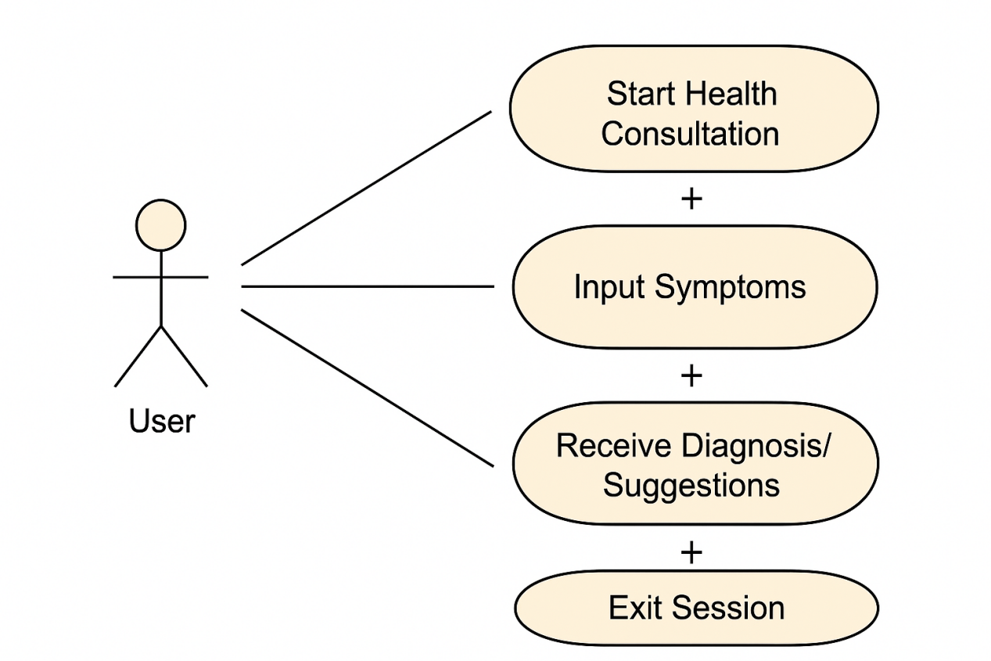
Start Quickcare AI
Figure 1
5.1.1 Use case name: Start Quickcare AI
Attribute | Description
Pre-condition | User has access to the system and opens the AI assistant
Basic Path | 1. User launches the application  2. System welcomes the user and initiates the session
Alternate Path | None
Post-condition | Session starts successfully and system is ready to accept input
Exception Path | System fails to start due to server or API error — an error message is shown

5.1.2 Use Case Name: Input Symptoms
Attribute | Description
Pre-condition | Health consultation session has started
Basic Path | 1. System prompts user to enter symptoms  2. User provides symptom details
Alternate Path | User enters vague or incomplete information — system asks clarifying questions
Post-condition | Symptoms are received and stored for analysis
Exception Path | User input is invalid (e.g., gibberish text) — system prompts for correction

5.1.3 Use Case Name: Receive Diagnosis/Suggestion
Attribute | Description
Pre-condition | System has received and analyzed symptoms
Basic Path | 1. System processes input  2. System returns possible diagnosis and suggestions
Alternate Path | If symptoms are unclear, system asks follow-up questions before proceeding
Post-condition | User receives medical information or advice
Exception Path | If model fails to process input — fallback to “Unable to determine” message

5.1.4 Use Case Name: Exit Session
Attribute | Description
Pre-condition | Session is ongoing
Basic Path | 1. User ends the consultation  2. System thanks the user and logs the session
Alternate Path | Session times out after inactivity
Post-condition | Session ends and all data is cleared/stored as needed
Exception Path | System crashes before proper session closure

5.2 Concepts and technologies:
The software requirements for the Quickcare AI project are:-
- Python (3.12.2)
- VS-CODE(Visual Studio Code)
- Groq API
- Elevenlabs API
- Gradio
- ffmpeg
- pyaudio
- Speech Recognition pydub
- Gtts

Python (3.12.2): A high-level, interpreted programming language known for its simplicity and readability. Version 3.12.2 includes performance improvements and new features for easier development.

VS Code (Visual Studio Code): A lightweight yet powerful source code editor developed by Microsoft. It supports debugging, syntax highlighting, Git integration, and extensions for various languages including Python.

Groq API: A fast and low-latency API provided by Groq Inc. designed to run large language models (LLMs) and AI workloads efficiently, offering real-time performance for inference tasks.

ElevenLabs API: A text-to-speech (TTS) API that uses advanced AI models to generate highly realistic and human-like speech from text input, commonly used in voice applications and narration.

Gradio: A Python library that allows you to quickly create interactive user interfaces for machine learning models and Python functions, making it easy to share demos via the web.

FFmpeg: A powerful open-source command-line tool used to process, convert, record, and stream audio and video files. It supports nearly every multimedia format.

PyAudio: A Python library that provides bindings for PortAudio, enabling audio input/output functionality such as recording and playing sound using Python.

SpeechRecognition: A Python library that enables speech-to-text functionality, supporting multiple speech engines and APIs like Google Web Speech API.

pydub: A simple Python library for manipulating audio files. It allows for tasks like slicing, concatenating, and exporting audio, often used with ffmpeg.

gTTS (Google Text-to-Speech): A Python library and CLI tool that interfaces with Google Translate’s text-to-speech API to convert text into spoken audio.

5.3 Hardware Requirement:

Component | Minimum Specification
Processor (CPU) | Intel i5 / AMD Ryzen 5 or equivalent
RAM | 8 GB or more
Storage | 256 GB SSD (or 500 GB HDD minimum)
Microphone | Basic external or internal microphone for voice input
Speaker/Audio | Basic speakers/headphones for audio output (TTS)
GPU (Optional) | NVIDIA GPU (e.g., GTX 1050+) if training models locally
Internet | Stable connection for API calls (e.g., OpenAI, ElevenLabs)
Webcam (Optional) | For face-based interaction in future scope

5.4 Software Requirement:

Component | Specification / Version
Operating System | Windows 10 / Ubuntu 20.04 or higher
Programming Language | Python 3.8+
Frameworks & Libraries | FastAPI, Transformers (Hugging Face), PyTorch / TensorFlow
Text-to-Speech | gTTS / ElevenLabs API
Speech Recognition | Whisper (OpenAI) / SpeechRecognition library
Frontend (Optional) | HTML, CSS, JavaScript (if using a GUI)
Database | SQLite / MongoDB / Firebase (optional)
Tools for Diagrams | Draw.io / Lucidchart / StarUML
API Integration Tools | Postman (for API testing)
Browser | Google Chrome / Firefox
IDE | VS Code / PyCharm

- COST/EFFORT ESTIMATION

6.1 Cost Estimation
The development cost of the Medical AI Assistant depends on the resources used, including hardware, software tools, and human labor. Here is a basic estimation assuming an academic or prototype-level project:
Item | Estimated Cost (INR)
Personal Computer / Laptop | 0 (Assumed already available)
Internet and Cloud Services (if any) | 1,000
Software Tools (Python, libraries) | 0 (Open-source)
AI/ML APIs (Optional - e.g., GPT API) | 1,500 (If using paid APIs)
Research & Documentation | 500
Miscellaneous (electricity, printing) | 500
Total Estimated Cost | ₹3,500 – ₹4,500
Note: Cost may increase if deployed in production using cloud servers or real-time medical APIs.

6.2 Effort Estimation (Person-Hours)
Phase | Estimated Hours
Requirements Gathering | 5
System Design (UML, flowcharts) | 8
Backend Development (AI logic) | 15
Frontend/Interface Development | 10
Integration & Testing | 12
Debugging & Optimization | 10
Documentation & Reporting | 8
Total Estimated Effort | 68 hours
Assuming 1 developer working part-time (4 hours/day), the project can be completed in approximately 17 days.

- UML CLASS DIAGRAM
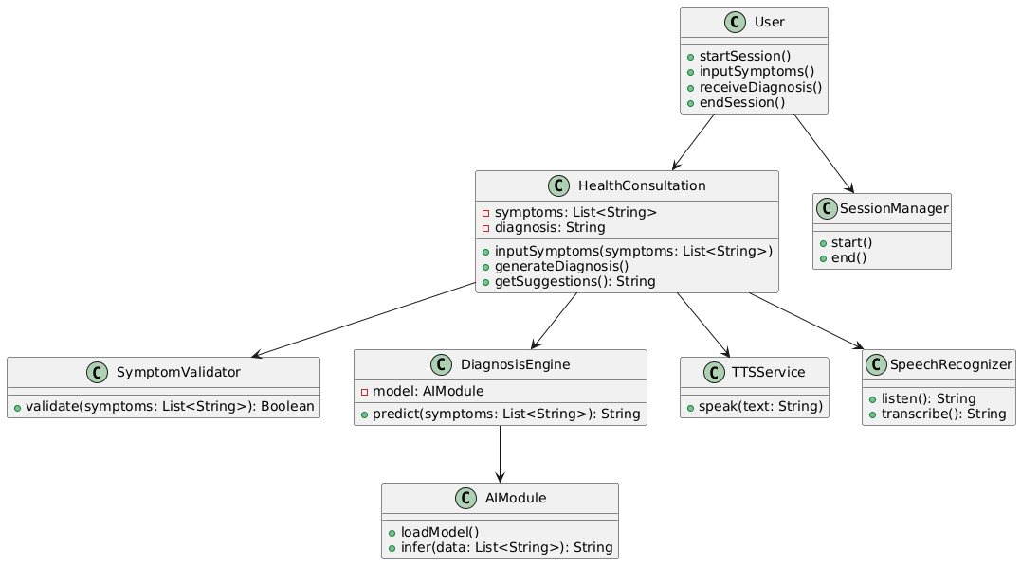
Figure 2
(A) Attributes:-
- GROQ_API_KEY in BrainOfTheDoctor
- ELEVENLABS_API_KEY in VoiceOfTheDoctor
- system_prompt in GradioApp

(B) Methods:-
- Public: process_input(), encode_image()
- Private: play_audio_file()

(C) Visibility Scope:-
- Private (e.g., API keys)
- Public (e.g., main methods)
- Protected (inherited attributes)

(D) Associations:-
- GradioApp --> BrainOfTheDoctor : "1..1"
- VoiceOfTheDoctor --> ElevenLabsAPI : "1..*"

(E) Generalization:-
- BrainOfTheDoctor --|> MedicalService
- Abstract class MedicalService with shared api_key

(F) Inheritance:-
- Child classes inherit from MedicalService
- Overrides validate_credentials()

(G) Aggregation:-
- Quickcare AI aggregates all components
- Lifetime control without strict ownership

- ENTITY RELATIONSHIP DIAGRAM

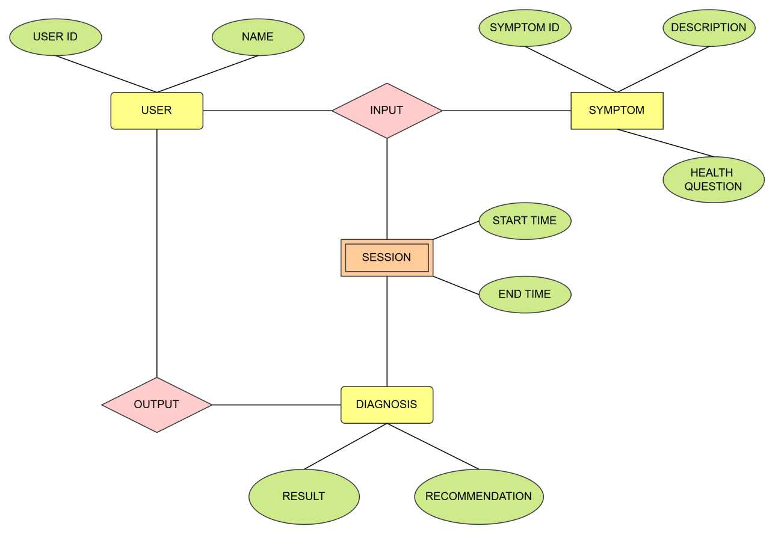
Figure 3
The Entity Relationship Diagram (ERD) represents the logical structure of the database used in the Quickcare AI . It illustrates the major entities involved in the system, their attributes, and the relationships among them. This model helps in understanding how data flows and is connected within the application.
- User
Represents the individuals interacting with the QUICKCARE AI . Each user can initiate multiple health consultation sessions.
- Session
Captures details of each health consultation initiated by a user. It tracks the start and end time of a session and is associated with the symptoms and diagnosis for that session.
- Symptom
Stores information about symptoms reported by the user during a session.
- Diagnosis
Represents the outcome generated by the AI based on the symptoms provided. Each session has one diagnosis.
- HealthQuestion
Stores questions asked by the user during a session, such as follow-up queries or general health doubts.

- SEQUENCE DIAGRAM
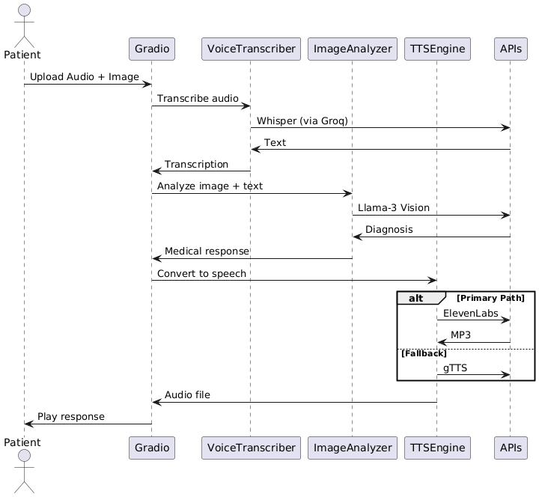
Figure 4
9.1 PURPOSE OF SEQUENCE DIAGRAM:
The sequence diagram illustrates the interaction flow for a patient consultation using the Quickcare AI. It shows how audio and image data are processed to deliver a diagnosis and verbal response using multiple subsystems.

- Demonstrates the end-to-end workflow of a medical consultation.
- Shows integration between speech recognition, image processing, language modeling, and text-to-speech systems..
- Highlights decision paths (like TTS fallback) and how the system maintains response delivery.
9.2 Actors and Components:
- Patient: The end-user uploading symptoms via voice and images.
- Gradio: The interface platform used to collect user inputs.
- VoiceTranscriber: Module responsible for converting speech to text using Whisper.
- ImageAnalyzer: Processes visual symptoms using a vision model (LLaMA-3)
- TTSEngine: Text-to-speech module for converting the AI's response into audio.
- APIs: External APIs like Whisper, LLaMA-3 Vision, ElevenLabs, and gTTS.

9.3 Interaction Steps:-
- Upload Audio + Image:
The patient provides an image and audio description of their symptoms through the Gradio interface.
- Transcribe Audio:
Gradio sends the audio to the VoiceTranscriber, which uses Whisper via Groq for transcription.
- Return Text:
Whisper returns the text result, which is sent back through the VoiceTranscriber.
- Analyze Image + Text:
The transcription and image are sent to ImageAnalyzer, which uses LLaMA-3 Vision for multimodal analysis.
- Get Diagnosis:
The ImageAnalyzer processes the input and fetches a medical response or diagnosis.
- Convert to Speech:
The diagnosis is sent to TTSEngine to convert the text response to speech.
- TTS Paths:
Primary Path: ElevenLabs is used to generate an MP3 file.
Fallback: If ElevenLabs fails, gTTS (Google Text-to-Speech) is used.
- Play Response:
The final audio file is returned to the Gradio interface and played for the patient.

10. Input Validations and Checks
The Quickcare AI processes multi-modal data inputs (audio and image) from users. To ensure data quality, user safety, and robust system performance, input validation and verification checks are performed at each stage of the interaction. These validations help prevent faulty diagnoses, system errors, or service disruption due to corrupted or unsupported inputs.

1. Audio Input Validation
File Format Check: Accept only supported audio formats (e.g., .wav, .mp3, .m4a).
Duration Check: Ensure the audio is neither too short (<2 seconds) nor too long (>60 seconds) to maintain relevance and avoid processing overload.
Noise Detection: Use pre-processing filters to detect and warn users about poor audio quality (e.g., background noise, unclear speech).
Language Consistency: Validate if the spoken language is within supported languages (e.g., English) using Whisper’s language detection capabilities.

2. Image Input Validation
File Type Validation: Accept standard image formats like .jpg, .jpeg, .png.
Size Validation: Check for minimum and maximum file size limits (e.g., 100KB – 5MB).
Resolution Check: Validate that the image resolution is sufficient for visual diagnosis (e.g., at least 300x300 pixels).
Content Validation:
Use pre-check models or heuristics to ensure the image is relevant (e.g., body parts, skin conditions, etc.).
Block inappropriate or unrelated images.

3. Combined Input Consistency
Synchronized Upload: Ensure both audio and image are uploaded in the same session.
Missing Input Checks: Notify users if either image or audio is missing before proceeding.
File Size Total Limit: Set a combined file size cap (e.g., <10MB) to avoid upload bottlenecks.

4. Text Processing Validation (Post Transcription)
Empty Text Check: Reject or re-request if transcribed text is too short or meaningless (e.g., only "uh", "hmm").
Sensitive Content Filter: Apply NLP-based filters to detect offensive, violent, or inappropriate content.
Grammar & Structure: Validate for basic sentence structure to improve AI understanding.

5. Diagnosis and Response Validation
AI Output Length: Ensure diagnosis is of acceptable length (e.g., 20–300 words).
Toxicity Check: Use moderation APIs (like OpenAI's content moderation) to ensure the diagnosis response is safe and professional.
Fallback Handling: If LLaMA-3 Vision fails, use a default response or retry with a simplified prompt.

6. Text-to-Speech (TTS) Output Validation
Speech File Check: Ensure audio is correctly generated and is playable.
Fallback Handling:
If ElevenLabs fails, system automatically falls back to gTTS.
Ensure MP3 format is supported across all fallback paths.

7. Session Control and General Checks
Session Timeout: Automatically terminate inactive sessions after a certain period (e.g., 5 minutes).
Input Rate Limiting: Prevent abuse by limiting number of uploads per minute per user.
User Confirmation: Prompt the user to confirm that inputs are accurate before submission.

11. Description of Different Reports
The system generates several reports to facilitate user understanding, developer monitoring, and data analysis. Below is a detailed description of the key reports included in the project:

1. Patient Consultation Report
Purpose: To summarize each patient’s consultation session.
Contents:
Patient ID or session ID
Date and time of consultation
Symptoms (as described or transcribed)
Uploaded image (thumbnail or path reference)
Diagnosis/medical suggestion generated by the AI
TTS audio file path or playback link
Confidence score of diagnosis (if applicable)
Use: Shared with the patient for review and saved in the database for future references or follow-up.

2. System Performance Report
Purpose: To track and monitor the health of the system modules.
Contents:
Number of sessions per day/week
Average response time per module (Transcription, Vision, TTS)
Module uptime/downtime
Error rates and fallback usage (e.g., how often gTTS was used instead of ElevenLabs)
API latency or failure metrics
Use: Helps developers detect bottlenecks, performance drops, or module failures.

3. Usage Analytics Report
Purpose: To analyze user interaction trends and platform usage.
Contents:
Number of users per day/week/month
Frequency of uploads (audio, image)
Common symptoms entered
Most requested specializations (e.g., skin issues, dental, etc.)
Device/browser usage breakdown
Use: Useful for understanding user behavior and making feature or UX improvements.

4. Error & Exception Report
Purpose: To log and report errors encountered during sessions.
Contents:
Session ID and timestamp
Type of error (upload failure, transcription timeout, TTS conversion fail, etc.)
Module where the error occurred
Error message or stack trace (for developers)
Action taken (e.g., fallback used or user prompted again)
Use: Aids in debugging and system reliability improvements.

5. Model Feedback Report
Purpose: To log performance and relevance of AI-generated outputs.
Contents:
Diagnosis response
Model used (e.g., LLaMA-3 Vision version)
Length and content quality of diagnosis
Optional user feedback or rating
Detected toxicity or flagging results (from moderation tools)
Use: Assists in improving future model fine-tuning or prompt engineering.

6. Security and Access Log Report
Purpose: To ensure secure and traceable use of the system.
Contents:
User login/logout timestamps (if authentication used)
IP address logs
Upload attempts (valid and invalid)
API key usage statistics
Suspicious activity alerts
Use: Supports compliance, audit logging, and security reviews.

- Sample Test Cases

A. White Box Testing

Module 1: Symptom Input & Validation

1. Flow Graph
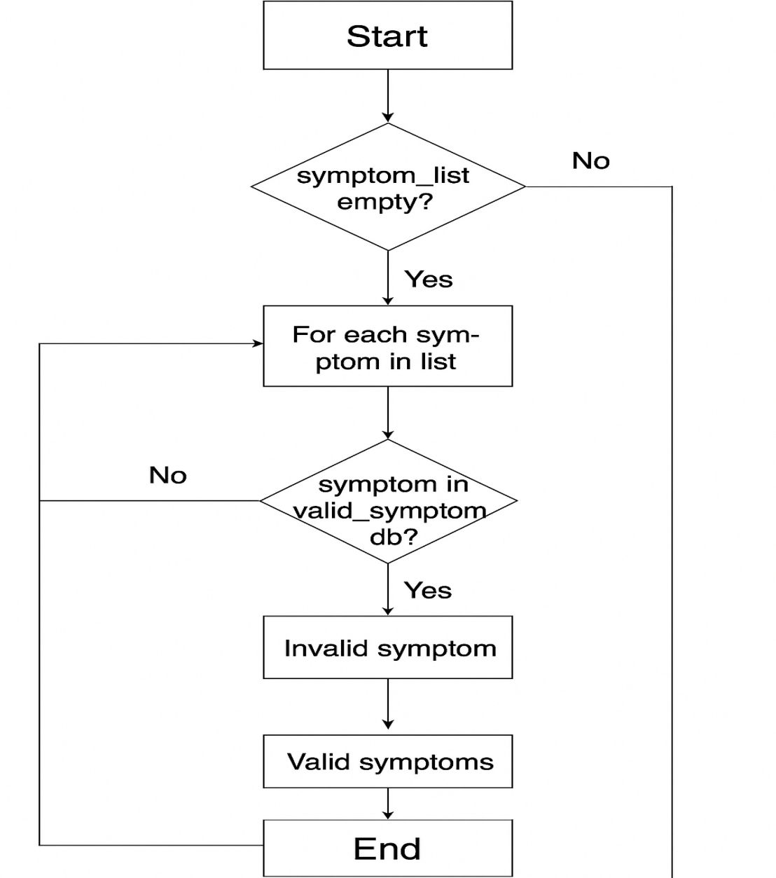
Figure 5

2. Cyclomatic Complexity
V(G) = E - N + 2P
Nodes (N) = 7, Edges (E) = 8, P = 1 (single program)
V(G) = 8 - 7 + 2 = 3

3. Independent Paths
Input is empty → return “No symptoms entered”
All symptoms valid → return “Valid symptoms”
At least one invalid symptom → return “Invalid symptom”

12.1. White Box Test Cases

Test Case ID | Input | Expected Output | Path Taken
WTC-1 | [] | “No symptoms entered” | Path 1
WTC-2 | [‘fever’, ‘cough’] | “Valid symptoms” | Path 2
WTC-3 | [‘headache’, ‘blarg’] | “Invalid symptom” | Path 3

12.2 . Black Box Testing

Use Case 1: Start Health Consultation (Input Symptoms)
Techniques Used: Equivalence Class Partitioning + Boundary Value Analysis

Test Cases:-

Test Case ID | Input | Expected Output | Valid Class?
BTC-1 | Empty input | Prompt for symptoms | Invalid
BTC-2 | One symptom only | Prompt for more input | Invalid
BTC-3 | Two valid symptoms | Proceed to diagnosis | Valid
BTC-4 | Symbols/Numbers as input | Reject input | Invalid
BTC-5 | Symptoms from valid set | Accepted | Valid

Use Case 2: Receive Diagnosis/Suggestions
Technique Used: Decision Table Based Testing
Condition: Valid Input? | Model Confidence High? | Expected Output
No | - | Prompt to re-enter
Yes | Yes | Provide diagnosis/suggestion
Yes | No | Suggest seeing a doctor

12.3 Test Cases:-

Test Case ID | Input | Model Confidence | Expected Output
BTC-6 | Empty/Invalid symptoms | - | Prompt to re-enter
BTC-7 | [‘fever’, ‘cough’] | High | Suggest Flu, take rest etc.
BTC-8 | [‘xyz’, ‘abc’] | Low | Recommend doctor visit

- Snapshots of the Different Input and Output Screens
Input
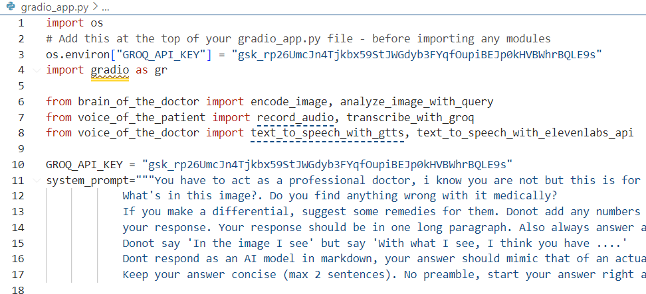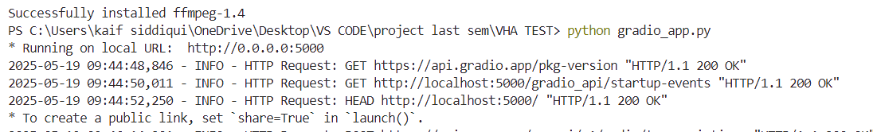
Output
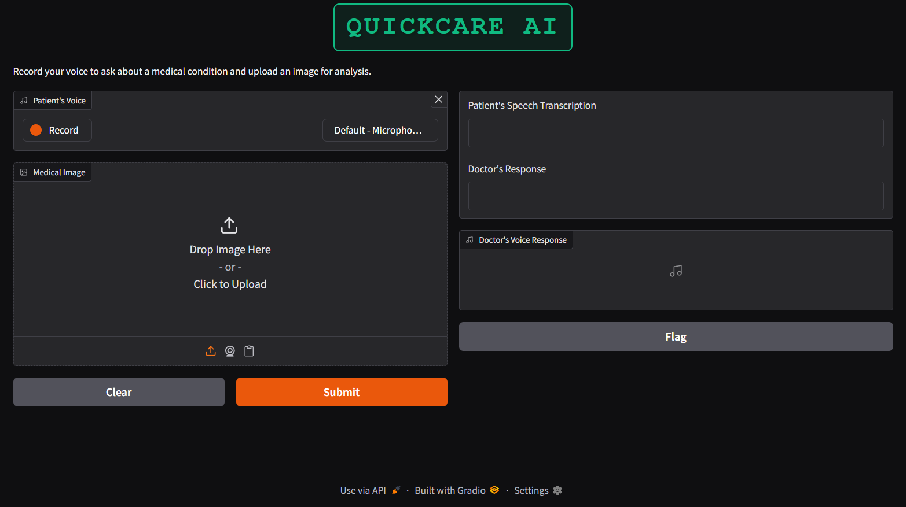
Figure 6

Title & Branding:
At the top, the app prominently displays the title QUICKCARE AI, giving the user immediate context about the application's purpose.
Voice Input Section:
Users can record their voice describing symptoms or concerns by clicking the “Record” button.
A microphone input selector allows users to choose the appropriate input device.
Image Upload Section:
Patients can upload or drag-and-drop an image (e.g., of a skin condition or medical report).
This supports AI image analysis as part of the diagnosis.
Submission & Control Buttons:
A Submit button initiates the diagnostic process.
A Clear button resets the interface for new input.

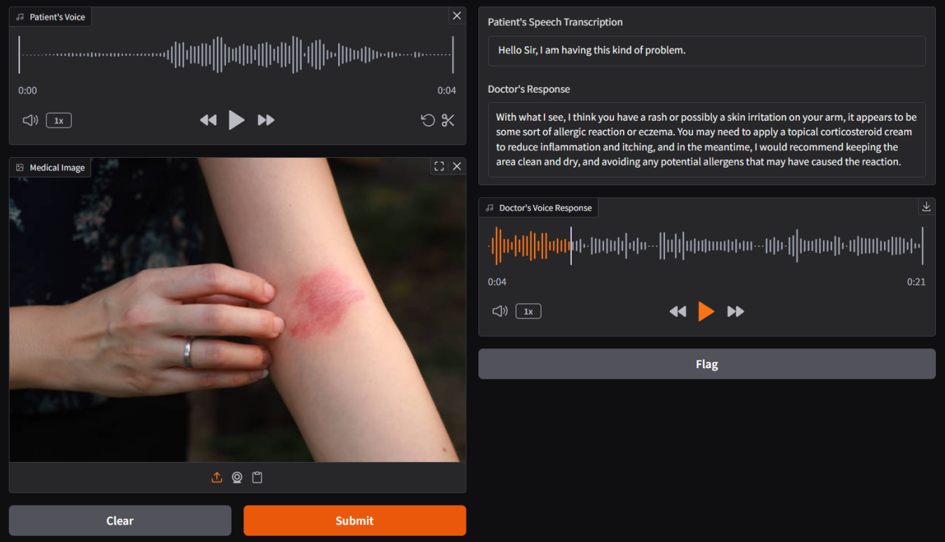
Figure 7
AI-Generated Results Panel:
On the right side, the patient’s voice transcription appears first.
This is followed by the AI-generated medical response, based on both voice and image inputs.
Doctor’s Voice Response:
The doctor’s response is also converted to speech using a Text-to-Speech (TTS) engine.
A waveform visual and playback controls allow users to listen to the response.
Image & Audio Playback:
Uploaded images are shown clearly.
Audio input and response playback are supported with speed and navigation controls.

Functional Summary
The UI enables multi-modal input (voice + image).
Provides AI-based diagnosis using LLM and vision models.
Offers a human-like, accessible output using text and voice.
Built for ease of use for patients, even those unfamiliar with complex interfaces.

CONCLUSION
The development of the Quickcare AI demonstrates the transformative potential of artificial intelligence in the field of healthcare. By leveraging multimodal inputs audio and images and integrating advanced models like Whisper for speech-to-text, LLaMA-3 Vision for diagnosis, and ElevenLabs/gTTS for speech synthesis, this system provides users with an interactive, accessible, and intelligent medical consultation experience.
This AI-driven platform not only streamlines the preliminary diagnostic process but also offers a scalable solution for areas with limited access to professional healthcare. The integration of robust validation checks, fallback mechanisms, and user-friendly interfaces ensures reliability, safety, and usability.
Moreover, the system’s modular architecture allows for future enhancements, such as integration with Electronic Health Records (EHR), support for multilingual diagnosis, and incorporation of biometric or sensor data. With proper medical oversight and continuous refinement, the Quickcare AI holds the potential to significantly reduce the burden on healthcare professionals and democratize access to basic medical advice across the globe.
In conclusion, this project serves as a strong foundation for building AI-assisted healthcare systems that are not only technically efficient but also aligned with the goal of inclusive and ethical medical support.

LIMITATION
While the Medical AI Assistant showcases promising capabilities, it also has several limitations that must be acknowledged to ensure responsible use and future improvements:

1. Not a Substitute for Professional Medical Advice
The system provides preliminary suggestions and general guidance only.
It cannot replace a certified doctor’s diagnosis, prescription, or emergency care.
Users must be advised to consult a healthcare provider for any serious or urgent conditions.

2. Limited Medical Scope
The AI models are not trained on comprehensive clinical data.
The system may perform well on common or surface-level symptoms but struggle with complex or rare diseases.
It lacks integration with patient history, vitals, or reports for deeper analysis.

3. Dependence on Input Quality
Incorrect or unclear audio and image inputs can lead to inaccurate diagnoses.
Background noise, poor lighting, or low-resolution images reduce model accuracy.
Transcription or vision model errors may propagate downstream and affect the final response.

4. Language and Accent Barriers
Although Whisper supports many languages, regional accents or dialects may affect transcription accuracy.
The system’s understanding and response are limited to the language(s) supported by the LLM and TTS engines.

5. Model Bias and Limitations
The underlying AI models may reflect biases present in their training data.
This can affect fairness and accuracy, especially across diverse populations and medical conditions.

6. No Real-Time Physician Oversight
The system operates in a fully automated mode without live validation or review from a medical professional.
Inappropriate, misleading, or unsafe advice could go unchecked.

7. Privacy and Security Risks
Although precautions are taken, handling sensitive health data (audio, images) always involves potential data privacy concerns.
Users must be informed about how their data is stored, used, or deleted.

8. Dependency on Third-Party APIs
The system heavily relies on third-party services (e.g., OpenAI, ElevenLabs, Groq).
Downtime, API limits, or policy changes from these services can affect system availability or performance.

FUTURE SCOPE
As technology and healthcare continue to evolve, the Quickcare AI can be significantly enhanced and expanded. The following future developments aim to improve performance, accessibility, and impact:

1. Real-Time Doctor Collaboration
The system can be upgraded to support live chat or video consultations with certified doctors, enabling a seamless transition from AI suggestions to human verification for critical cases.

2. Deep Medical Integration
Integration with hospital databases, wearable health monitors, and electronic health records (EHR) will allow the AI to provide more precise, history-aware diagnoses and improve patient outcomes.

3. Improved Diagnostic Intelligence
With further training on medical datasets, the AI can cover complex and rare diseases, handle multi-symptom analysis, and perform image-based detection for skin, eye, or dental conditions.

4. Offline and Edge Computing Capabilities
Developing lightweight versions of the models will allow offline use on mobile or embedded devices, especially beneficial in rural or low-connectivity areas.

5. Expanded Language and Regional Support
Future versions can support multilingual input, regional health advice, and local dialects, making the system usable across more communities worldwide.

6. Personalized Health Monitoring
By maintaining a user health history, the system can act as a virtual health assistant, giving reminders, suggesting wellness tips, and detecting trends in long-term conditions.

7. AI Ethics and Explainability
Incorporating explainable AI (XAI) methods will help users and doctors understand the reasoning behind diagnoses, increasing trust, transparency, and accountability.

8. Government and NGO Collaborations
The system can be deployed through government health missions or NGOs, particularly in underserved regions, supporting public health screening, awareness, and data collection.

9. Voice Interaction Enhancement
The conversational system can be improved using natural-sounding TTS, interactive questioning, and sentiment detection, allowing the assistant to guide users more intuitively.

10. Emergency and Mental Health Detection
AI models can be trained to detect emergency conditions (e.g., heart attack, stroke symptoms) or mental health risks (e.g., depression, stress), and trigger alerts or connect users to emergency services.

Bibliography
[1] OpenAI, “ChatGPT and GPT-4 Models,” OpenAI, 2024. [Online]. Available: https://openai.com/chatgpt
[2] OpenAI, “Whisper: Robust Speech Recognition via Large-Scale Training,” GitHub, 2022. [Online]. Available: https://github.com/openai/whisper
[3] Meta AI, “LLaMA 3: Open Foundation and Instruction Models,” Meta AI, 2024. [Online]. Available: https://ai.meta.com/llama/
[4] ElevenLabs, “AI Text-to-Speech Platform,” ElevenLabs, 2024. [Online]. Available: https://www.elevenlabs.io/
[5] Google Developers, “gTTS: Google Text-to-Speech,” Python Package Index (PyPI), 2024. [Online]. Available: https://pypi.org/project/gTTS/
[6] Python Software Foundation, “Python Programming Language,” Python.org, 2024. [Online]. Available: https://www.python.org/
[7] S. Tiangolo, “FastAPI - The Fastest Python Web Framework,” FastAPI Documentation, 2024. [Online]. Available: https://fastapi.tiangolo.com/
[8] Hugging Face, “Transformers Library,” Hugging Face, 2024. [Online]. Available: https://huggingface.co/docs/transformers
[9] Groq Inc., “Groq High-Speed AI Inferencing Platform,” Groq, 2024. [Online]. Available: https://groq.com/
[10] draw.io, “Diagram and UML Design Tool,” diagrams.net, 2024. [Online]. Available: https://www.draw.io/
[11] IEEE, IEEE Recommended Practice for Software Requirements Specifications, IEEE Std 830-1998, 1998.
[12] World Health Organization, “Artificial Intelligence in Health: A Tool for Enhancing Accessibility,” WHO, 2021. [Online]. Available: https://www.who.int/

- Plagiarism Report
[ Editpad.org ]
{Note: A separate report has been provided due to the word limitation of 1000 words on plagiarism detection websites.}

Therefore, Total Unique Content = 96%
Total Plagiarized Content = 4%

